**Contents**

NOTES: 2

Developing Immersive Applications: Quick run-through on extending XRAuthor 3

Updating XRAuthor 3

Cleaning up project files 4

Extending XRAuthor from the Standalone Web App 5

App 5

Possible Errors 10

Extension 11

Upload Extension to Server 13

Load Assets 15

Playing Video 19

Video Controls 24

Play Animation 28

How to find the id of the specific animation to bind your model to? 31

Animation Controls 32

Load and Animate Models 34

Adding Labels and Text to Models 36

Final Code Changes 39

init.ts 39

index.ts 40

webpack.config.js 41

app.ts 42

index-ext.ts 56

webpack.ext.js 57

# NOTES:

- If you haven’t done Part 1 yet, here’s the link to [Part 1](IPAsetup_part1.docx)

- If you haven’t done Part 2 yet, here’s the link to [Part 2](IPAsetup_part2.docx)

- If you haven’t done Part 3 yet, here’s the link to [Part 3](IPAsetup_part3.docx)

**TOPICS COVERED:**

* Separating Standalone App and XRAuthor Extension
* How to upload extension to XRAuthor server
* Load XRAuthor assets to project
* Play XRAuthor video on a VideoTexture plane
* Play/Pause XRAuthor video
* Play XRAuthor Model Animation
* Play/Pause XRAuthor Model Animation along with the video
* Load and animate the XRAuthor Models
* Displaying Labels on the XRAuthor Models

**FINAL CODE CHANGES:**

Skip to the final code changes:

Final Code Changes

Skip to the individual file changes:

init.ts

index.ts

webpack.config.js

app.ts

index-ext.ts

webpack.ext.js

# Developing Immersive Applications: Quick run-through on extending XRAuthor

<https://www.youtube.com/watch?v=oze68OIyZVM>

## Updating XRAuthor

Note: if you did not setup XRAuthor previously, you can follow this link to [setup XRAuthor](https://hub.docker.com/r/immersification/xrauthor).

If you already have XRAuthor in your device, follow the steps below to update XRAuthor:

Open powershell and cd to the path of your xrauthor-uploads folder

Enter the following commands:

docker stop xrauthor

docker rm xrauthor

docker pull immersification/xrauthor

docker run -dp 3000:3000 --mount type=bind,source="$(pwd)",target=/app/uploads --name xrauthor immersification/xrauthor

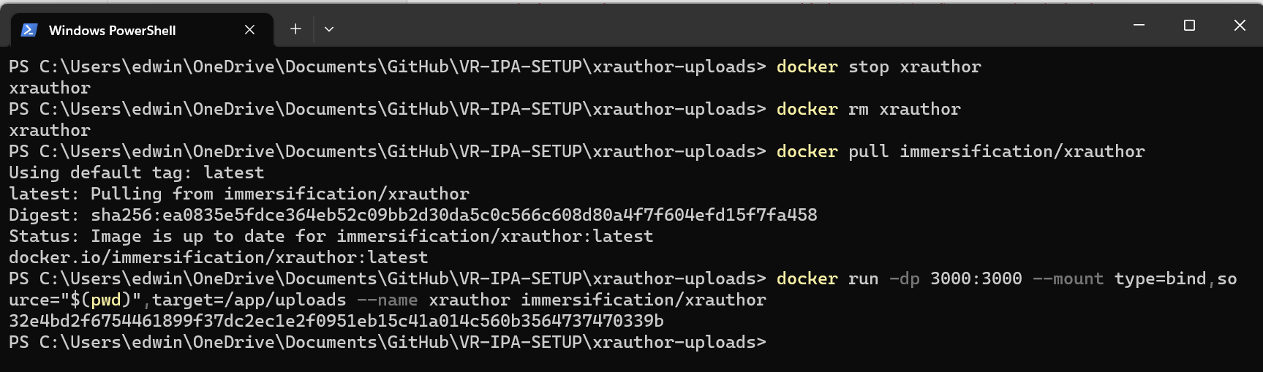

## Cleaning up project files

Enter the following commands:

cd src

rm *.d.ts

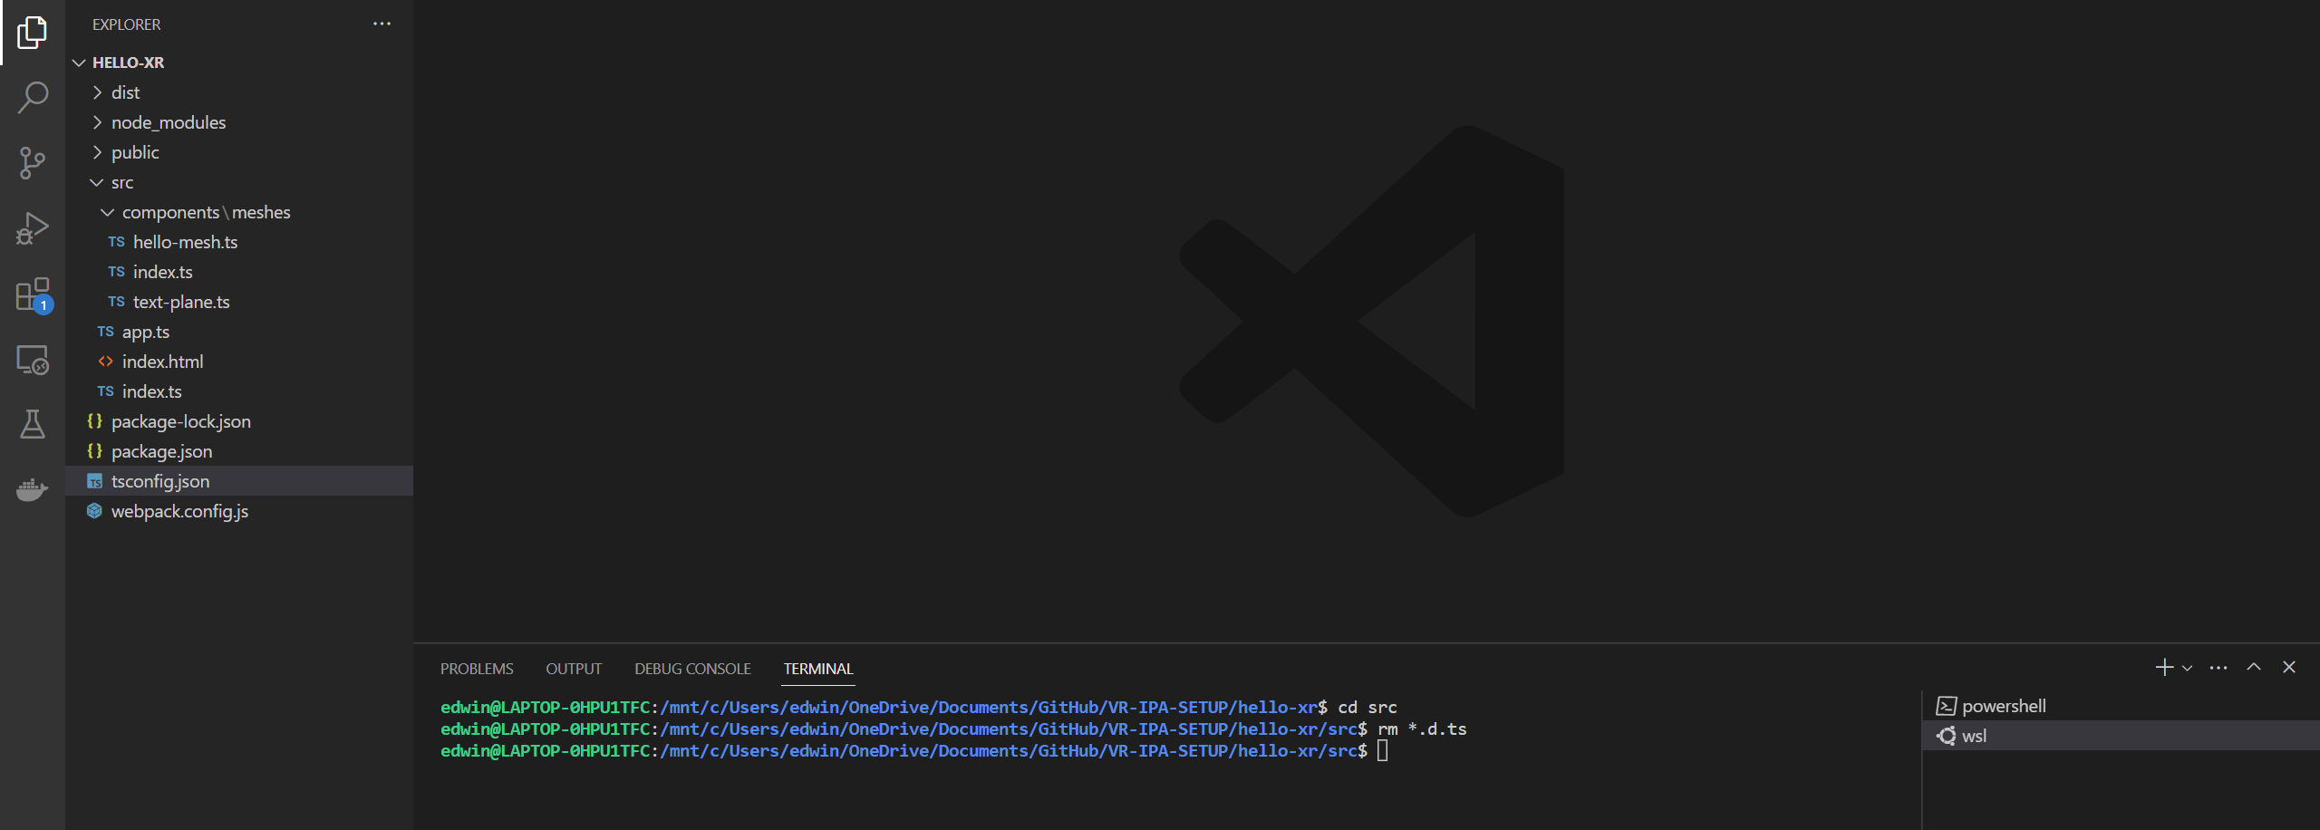

You should see the following files removed from your project:

Before:

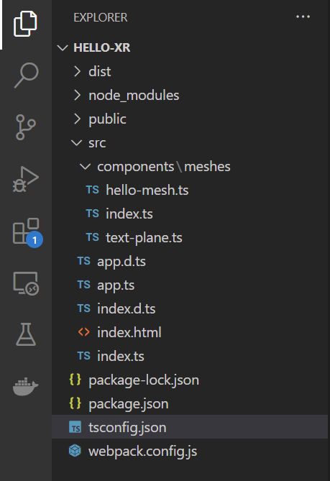

After:



## Extending XRAuthor from the Standalone Web App

### App

Enter the following commands:

cp index.ts init.ts

You should also see a “init.ts” file created.

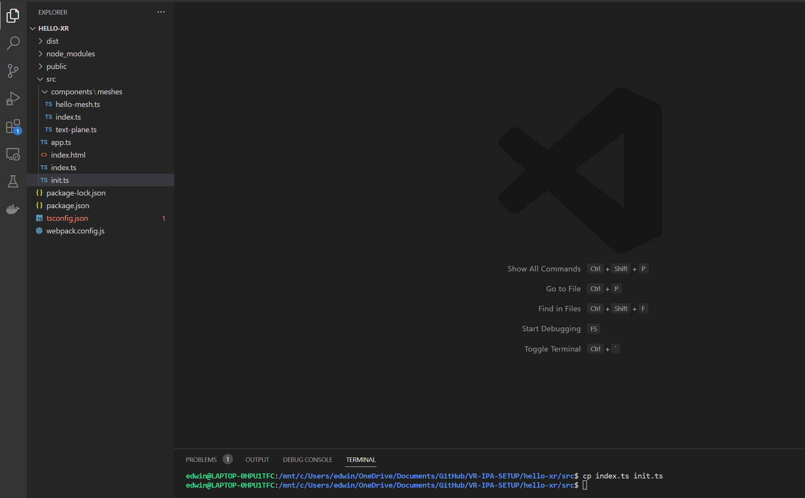

**init.ts**

Replace with the following codes:

import { Engine } from "babylonjs";

import { App } from "./app";

export function createXRScene(

  canvasID: string,

  // authoringData: {

  //   [dataType: string]: { [key: string]: any };

  // }

  authoringData: any,

) {

  const canvas = <HTMLCanvasElement>document.getElementById(canvasID);

  const engine = new Engine(canvas, true);

  const app = new App(engine, canvas, authoringData);

  const scene = app.createScene();

  const scenePromise = app.createScene();

  scenePromise.then((scene) => {

    engine.runRenderLoop(() => {

      scene.render();

    });

  });

  window.addEventListener("resize", () => {

    engine.resize();

  });

}

**index.ts**

Replace with the following codes:

import { createXRScene } from './init'

createXRScene('renderCanvas', 'hello from app!!! :D')

**webpack.config.js**

Change the port to 9000 instead of 3000, as XRAuthor is using port 3000.

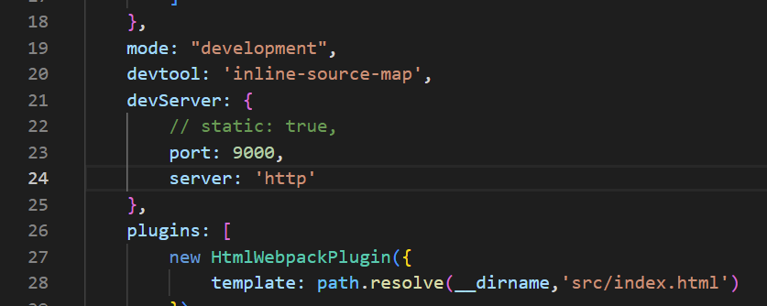

**app.ts**

Add the following codes:

private data: any;

Replace with the following codes:

constructor(engine: Engine, canvas: HTMLCanvasElement, data: any) {

Add the following codes:

this.data = data;

Add the following codes:

console.log(this.data)

Here:

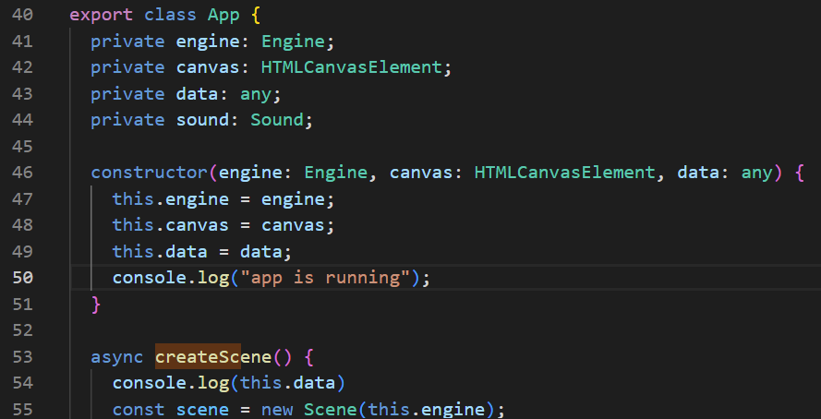

**Check**

You should be able to see the text “hello from app!!! :D” printed on the Console tab.

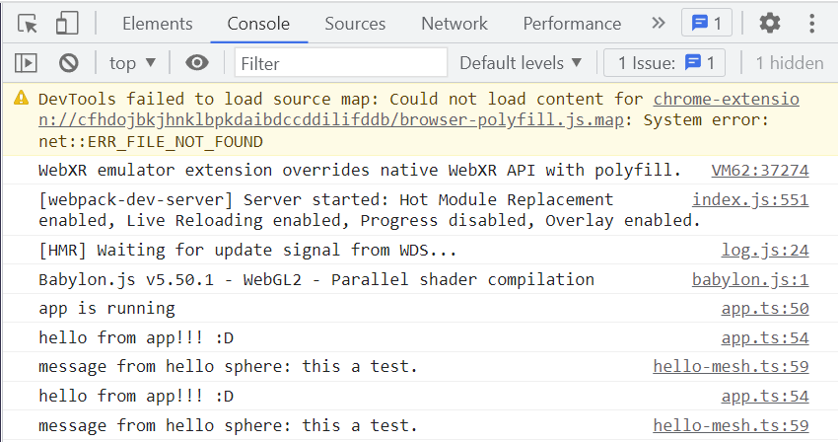

### **Possible Errors**

If you have met the following error: Cannot find global type 'IterableIterator'.ts  
You can try to replace “tsconfig.json” with the following codes:

{

    "compilerOptions": {

        "target": "es5",

        "module": "commonjs",

        "noResolve": false,

        "noImplicitAny": false,

        "removeComments": true,

        "preserveConstEnums": true,

        "sourceMap": true,

        "experimentalDecorators": true,

        "isolatedModules": false,

        "lib": [

            "dom",

            "es2015.promise",

            "es2015.iterable",

            "es5"

        ],

        //"declaration": true,

        "outDir": "./src",

        "types": [

            "babylonjs",

            "babylonjs-gui",

            "babylonjs-materials"

        ]

    },

    "files": [

        "./src/index.ts"

    ]

}

### Extension

Enter the following commands:

touch index-ext.ts

touch webpack.ext.js

You should be able to see “index-ext.ts” and “webpack.ext.js” file created.

**index-ext.ts**

Replace with the following codes:

import { createXRScene } from './init'

window['extension'] = { createXRScene: createXRScene }

**webpack.ext.js**

Replace with the following codes:

const path = require("path");

module.exports =

{

    entry: path.resolve(__dirname, 'src/index-ext.ts'),

    output: {

        filename: 'index.js',

        path: path.resolve(__dirname, 'dist/ext')

    },

    resolve: {

        extensions: ['.ts']

    },

    module: {

        rules: [

            { test: /\.tsx?$/, loader: "ts-loader" }

        ]

    },

    mode: 'production',

}

Enter the following commands:

npm run build-ext

You should be able to see a “ext” folder created under the “dist” folder.

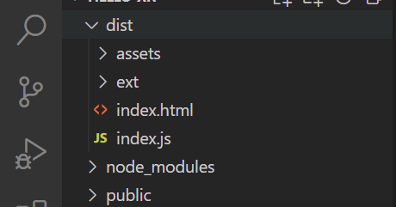

## Upload Extension to Server

Go to <http://localhost:3000/author> and record your video.

After you have finish recording your video, click on Complete editing then Publish.

Under “Upload the extension to the server” click on Choose File

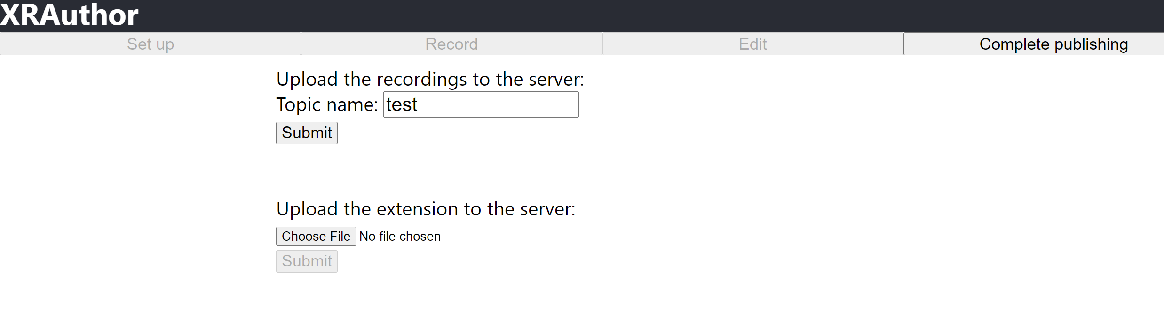

Navigate to hello-xr/dist/ext and click upload.

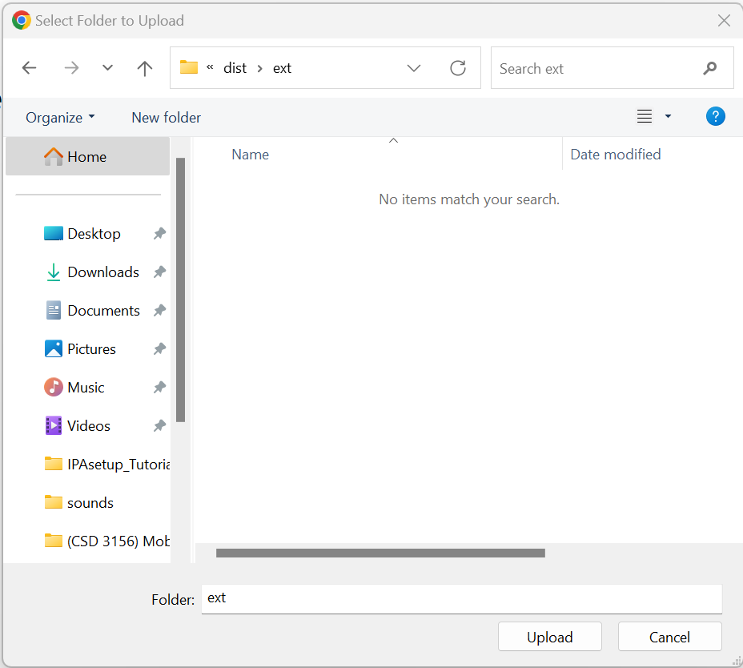

You should see 2 files uploaded.

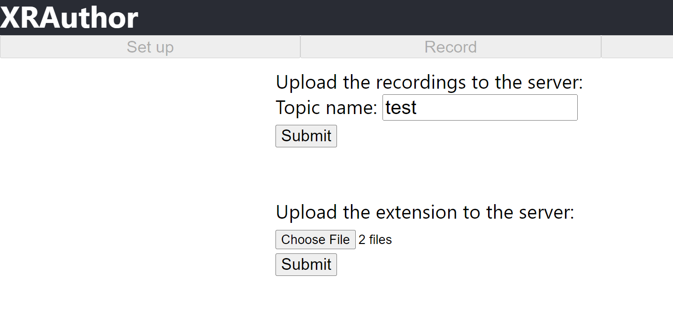

Click on Complete Publishing and click Edit. You should see a new XR Format tab added below your video. Click on the XR Format tab and your VR Web App should be shown.

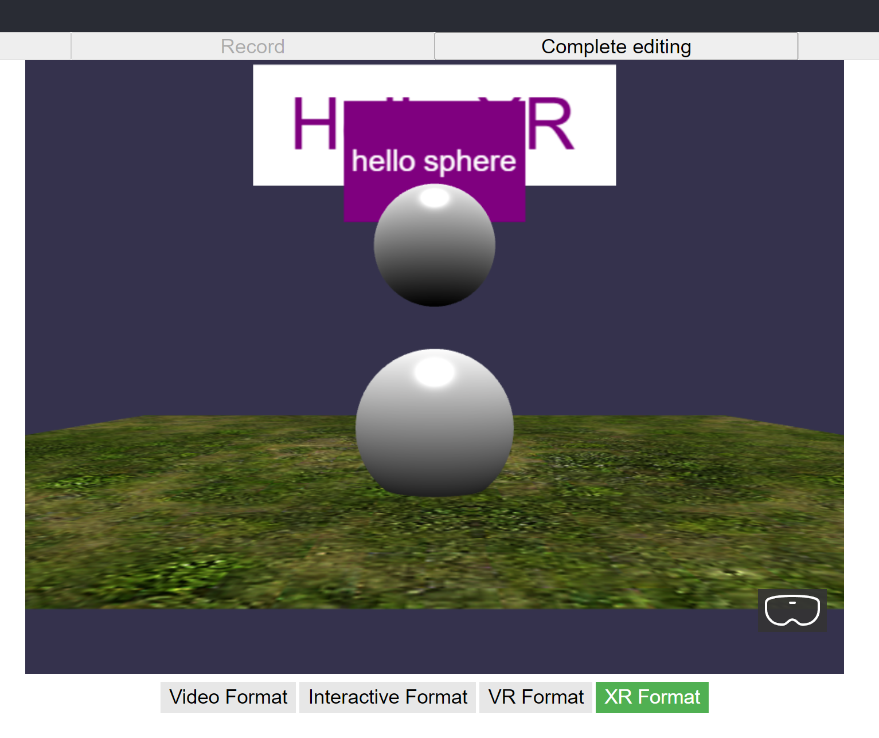

## Load Assets

**Webpack.config.js**

Comment out the following codes:

//static: false,

Here:

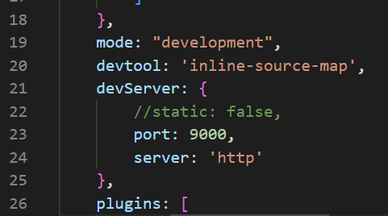

Navigate to xrauthor-uploads/assets and copy the test folder.

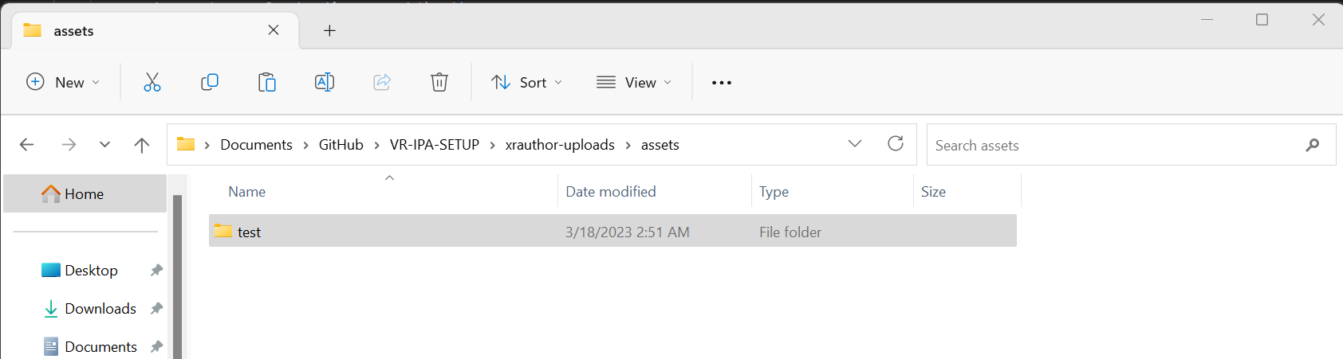

Paste the test folder in hello-xr-xrauthor/hello-xr/public/assets

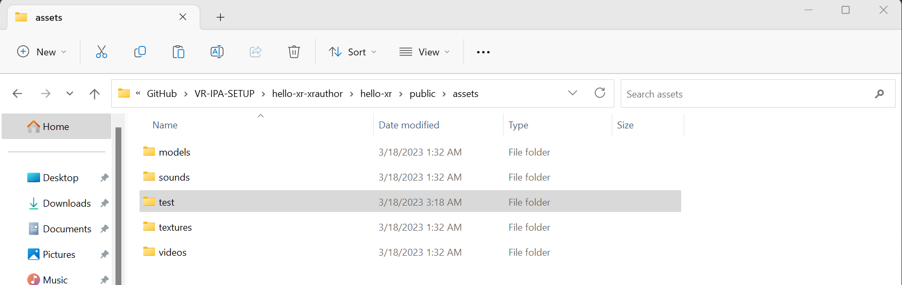

Enter the following commands:

npm i xrauthor-loader -D

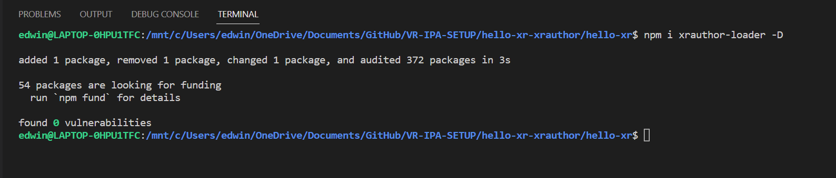

**app.ts**

Replace with the following codes:

private data: AuthoringData;

Replace with the following codes:

constructor(engine: Engine, canvas: HTMLCanvasElement, data: AuthoringData) {

Here:

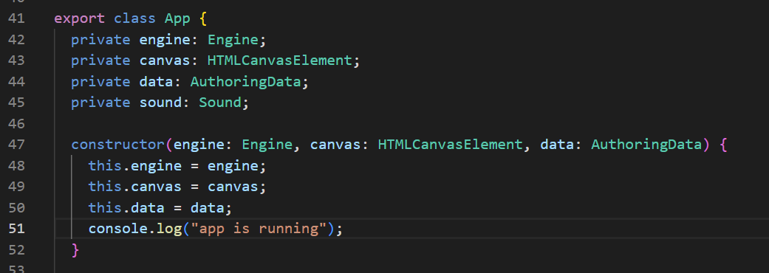

**index.ts**

Replace with the following codes:

import {AuthoringData, loadAuthoringData} from 'xrauthor-loader'

import {createXRScene} from './init'

loadAuthoringData('assets/test').then((data: AuthoringData) => {

    createXRScene('renderCanvas', data)

})

**init.ts**

Replace with the following codes:

authoringData: AuthoringData,

Here:

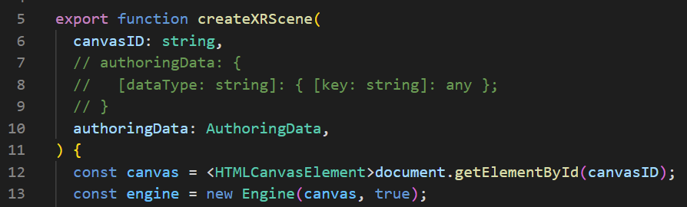

**Check**

You should see the AuthoringData shown in your Console tab.

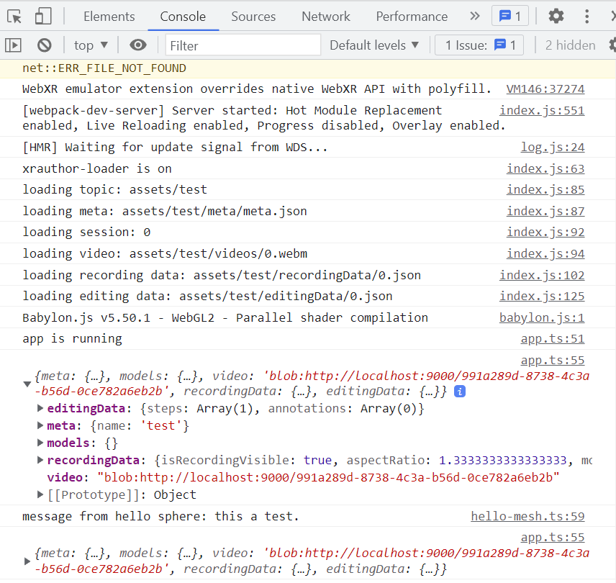

## Playing Video

Enter the following commands:

npm run build

**app.ts**

Add the following codes:

const videoHeight = 5;

    const videoWidth = videoHeight * this.data.recordingData.aspectRatio;

    const videoPlane = MeshBuilder.CreatePlane(

      "video plane",

      {

        height: videoHeight,

        width: videoWidth,

      },

      scene

    );

    videoPlane.position.z = 6;

    const videoMaterial = new StandardMaterial("video material", scene);

    const videoTexture = new VideoTexture(

      "video texture",

      this.data.video,

      scene

    );

    videoTexture.video.autoplay = true;

    videoMaterial.diffuseTexture = videoTexture;

    videoMaterial.roughness = 1;

    videoMaterial.emissiveColor = Color3.White();

    videoPlane.material = videoMaterial;

Here:

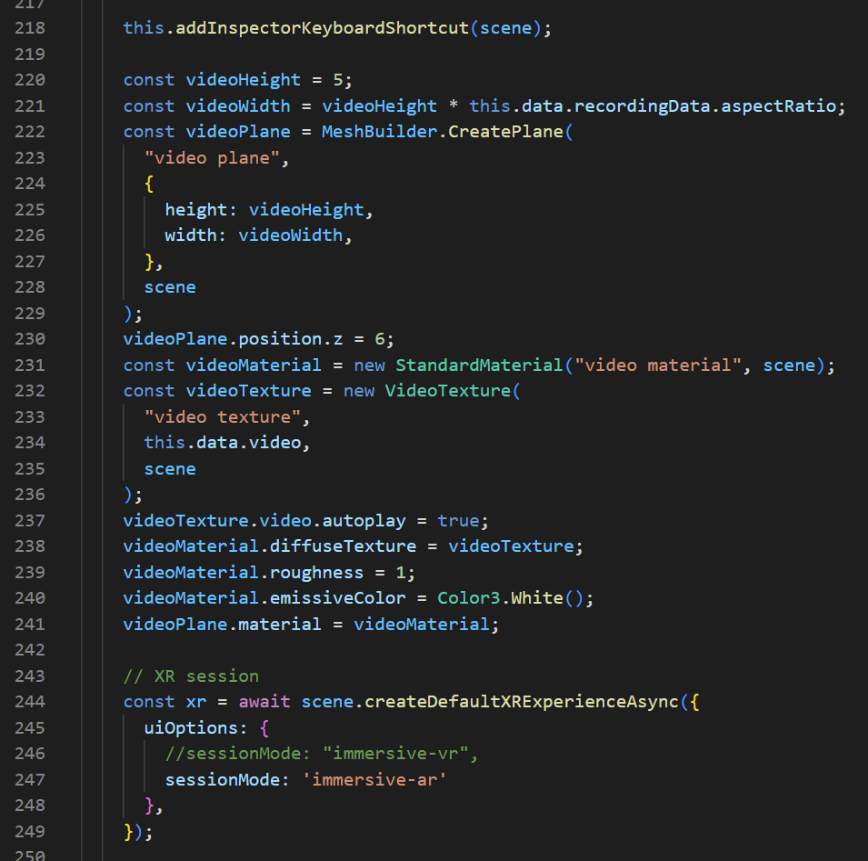

Comment out the following codes:

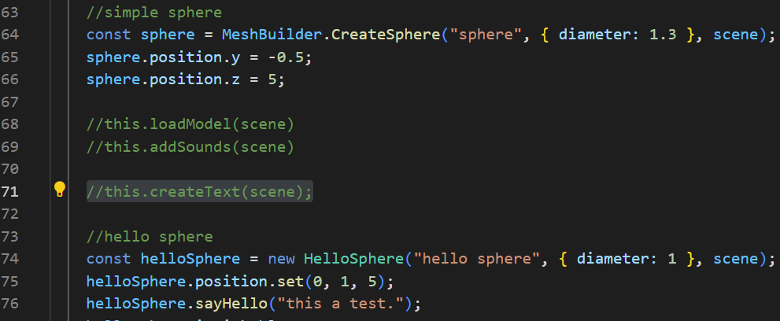

Comment out the following codes:

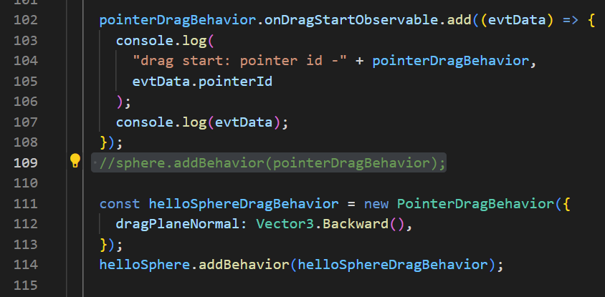

Comment out the following codes:

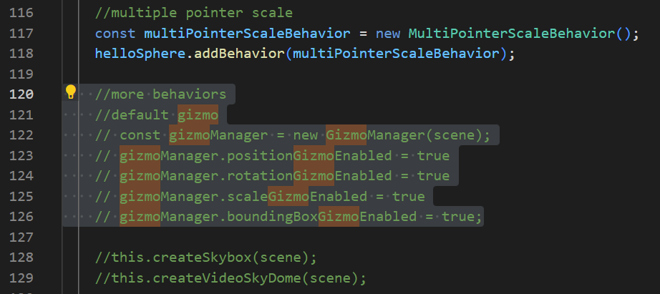

Add the following codes:

ground.setEnabled(false) //temporary disable

Here:

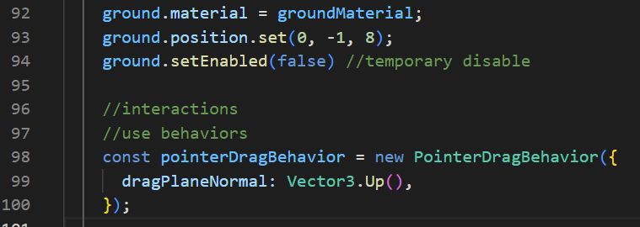

Add the following codes:

helloSphere.setEnabled(false) //temporary disable

Here:

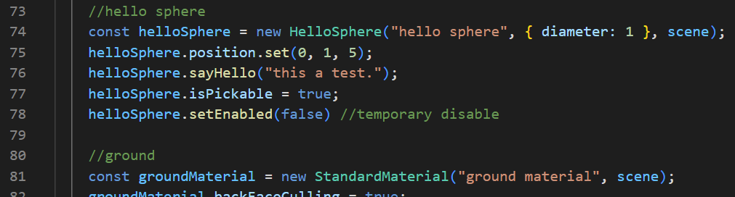

**Check**

You should be able to see a plane with your XRAuthor video rendered (and playing in the background), with a Sphere in front of it.

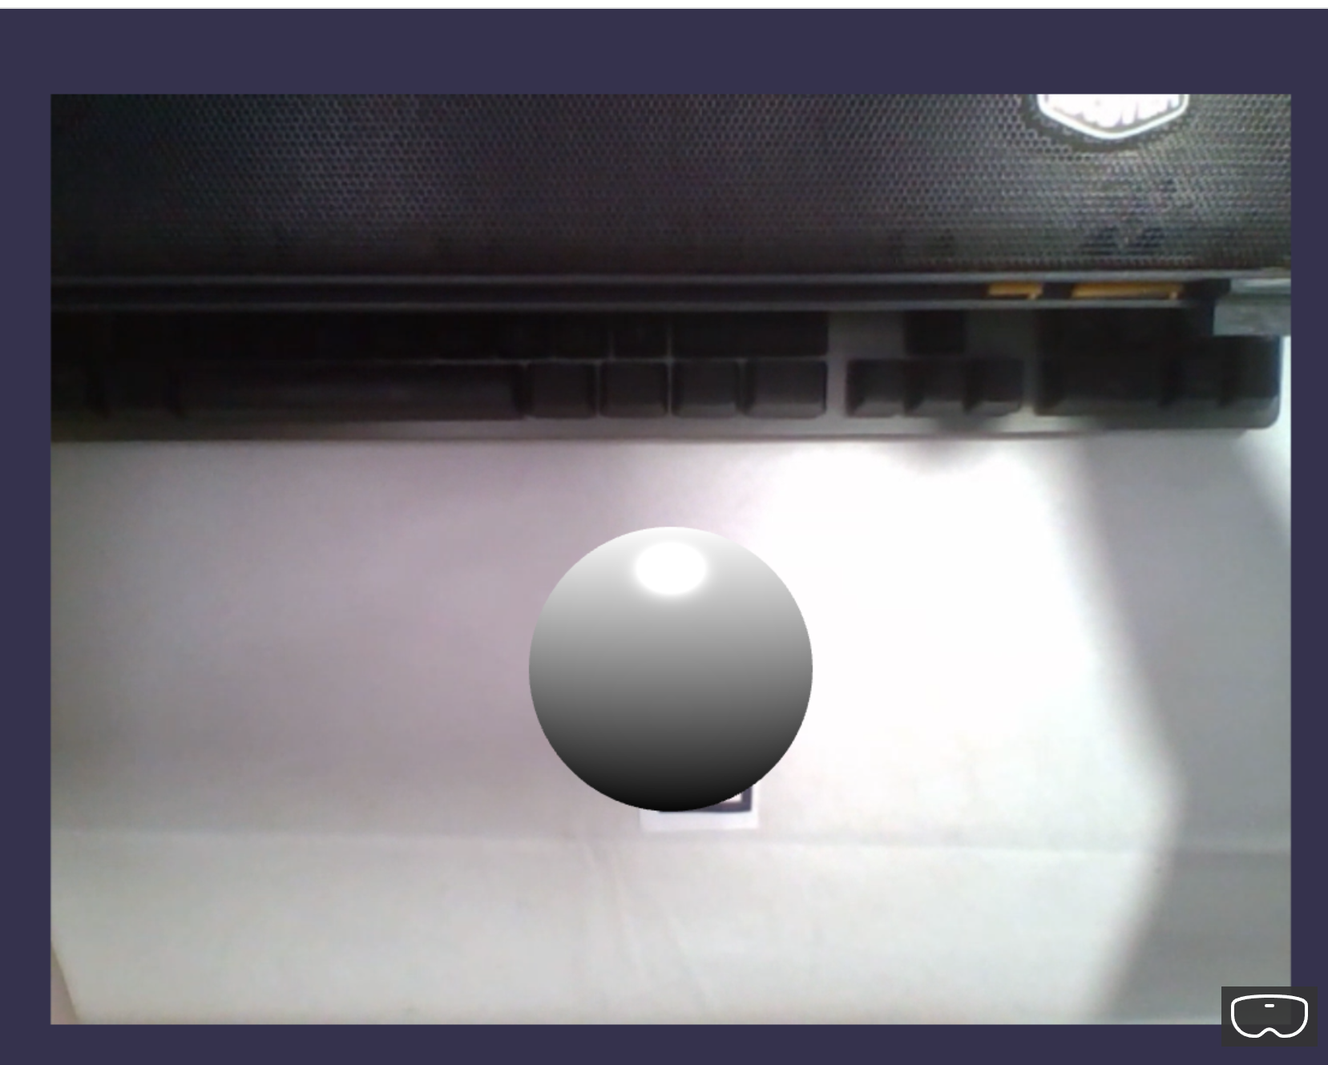

## Video Controls

**app.ts**

Replace with the following codes:

//XRAuthor Video

    const videoHeight = 5;

    const videoWidth = videoHeight * this.data.recordingData.aspectRatio;

    const videoPlane = MeshBuilder.CreatePlane(

      "video plane",

      {

        height: videoHeight,

        width: videoWidth,

      },

      scene

    );

    videoPlane.position.z = 6;

    const videoMaterial = new StandardMaterial("video material", scene);

    const videoTexture = new VideoTexture(

      "video texture",

      this.data.video,

      scene

    );

    videoTexture.video.autoplay = false;

    videoTexture.onUserActionRequestedObservable.add(()=> {})

    videoMaterial.diffuseTexture = videoTexture;

    videoMaterial.roughness = 1;

    videoMaterial.emissiveColor = Color3.White();

    videoPlane.material = videoMaterial;

    scene.onPointerObservable.add(evtData => {

      console.log('picked')

      if(evtData.pickInfo.pickedMesh === videoPlane){

        if(videoTexture.video.paused)

        {

          videoTexture.video.play()

        }

        else{

          videoTexture.video.pause()

        }

        console.log(videoTexture.video.paused ? 'paused' : 'playing')

      }

    }, PointerEventTypes.POINTERPICK)

Here:

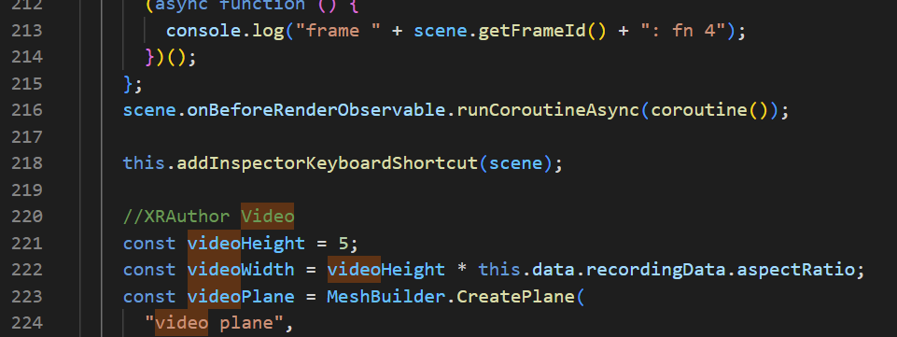

**Check**

You should be able to play/pause the video when you click on the plane with the XRAuthor video. The Console tab will also indicate “playing” or “paused” when you click on the video.

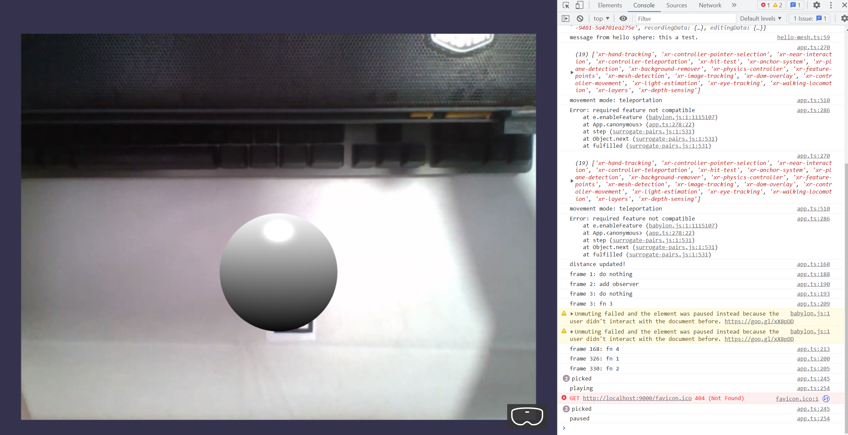

Enter the following commands:

npm run build-ext

Upload your extension to the server again.

You should be able to see your newly updated Web App reflected correctly on XRAuthor Edit mode.

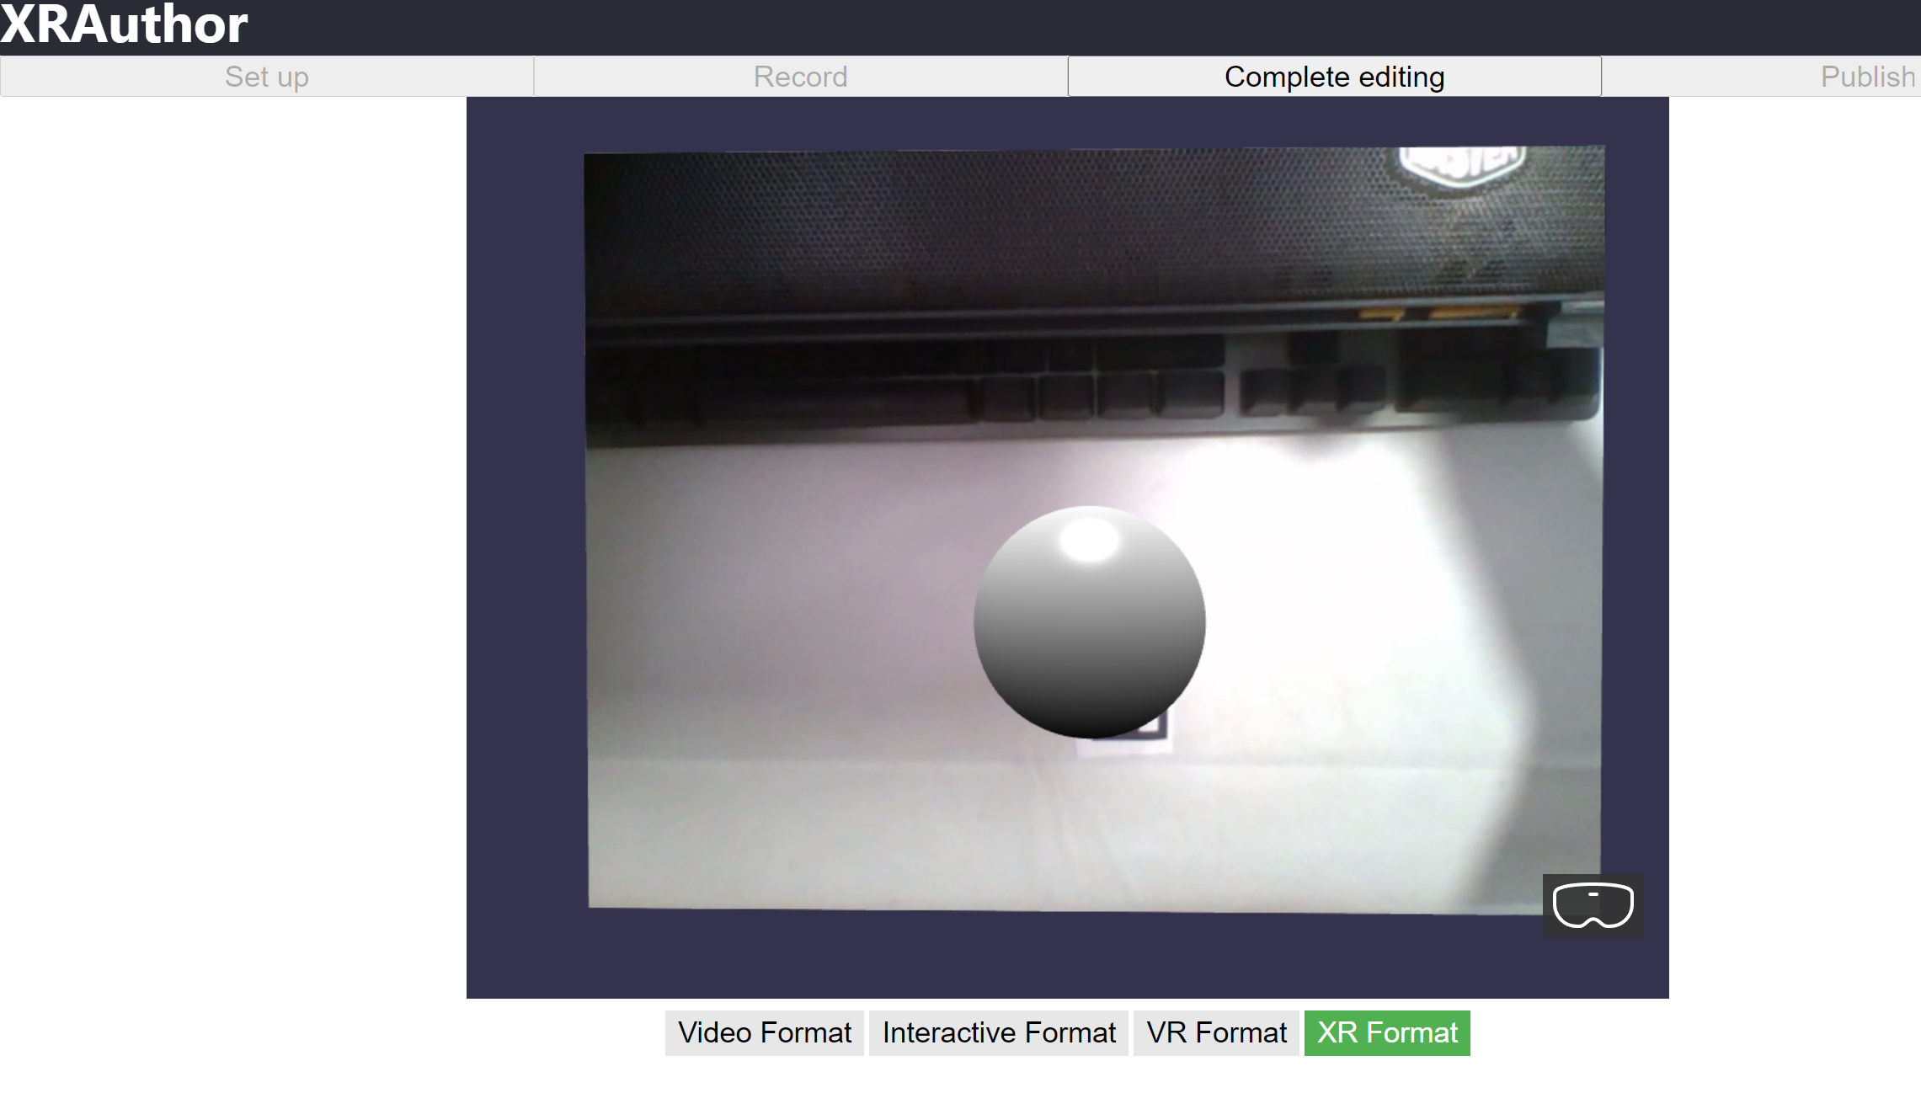

## Play Animation

**app.ts**

Add the following codes:

//XRAuthor Animation

    const id = "m10";

    const track = this.data.recordingData.animation.tracks[id];

    console.log("what value" + this.data.recordingData.animation.tracks)

    const length = track.times.length;

    const fps = length / this.data.recordingData.animation.duration;

    const keyFrames = [];

    for (let i = 0; i < length; i++) {

      const mat = Matrix.FromArray(track.matrices[i].elements);

      const pos = mat.getTranslation();

      //convert position from right handed to left handed coords

      pos.z = -pos.z;

      const s = 6 / pos.z;

      keyFrames.push({

        frame: track.times[i] * fps,

        value: pos.scale(s).multiplyByFloats(3, 3, 1),

      });

    }

    const animation = new Animation(

      "animation",

      "position",

      fps,

      Animation.ANIMATIONTYPE_VECTOR3,

      Animation.ANIMATIONLOOPMODE_CYCLE

    );

    animation.setKeys(keyFrames);

    sphere.animations = [animation];

    scene.beginAnimation(sphere, 0, length - 1, true);

Here:

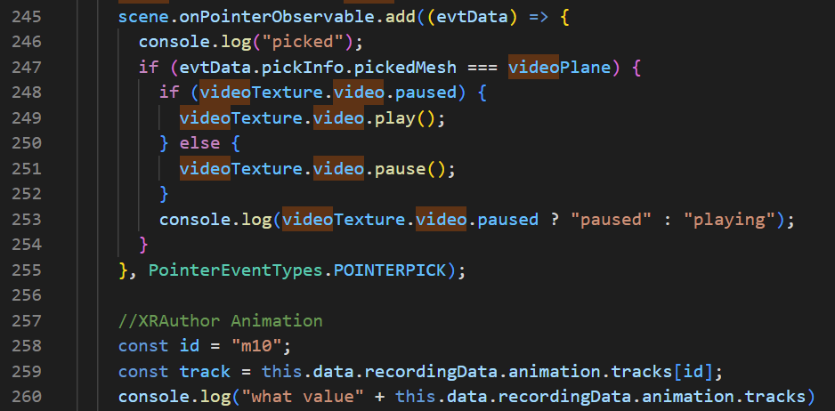

**Check**

You should see your Sphere moving according to your XRAuthor video’s QR code for that animation.

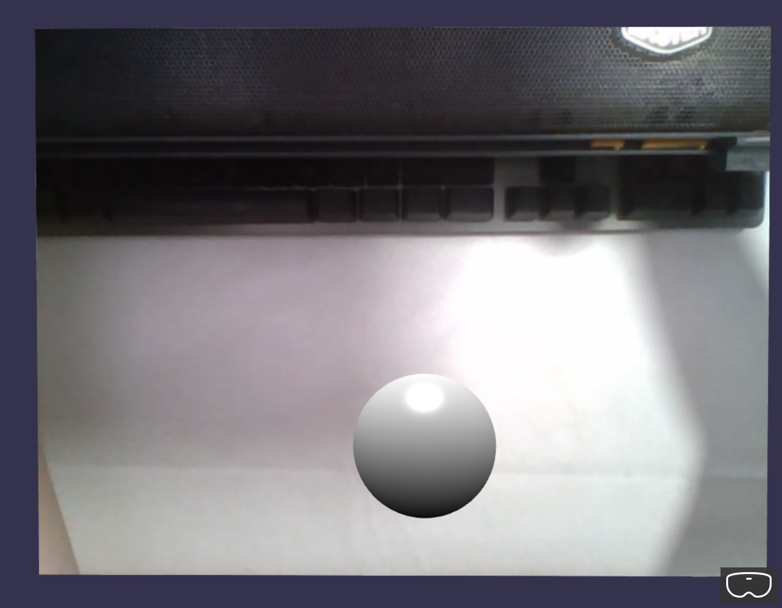

### How to find the id of the specific animation to bind your model to?

Under the Console tab, look for “recordingData > animation > tracks > m*”.

In my case, I am using the QR code (with label 10) in my XRAuthor video with the animation id “m10”.

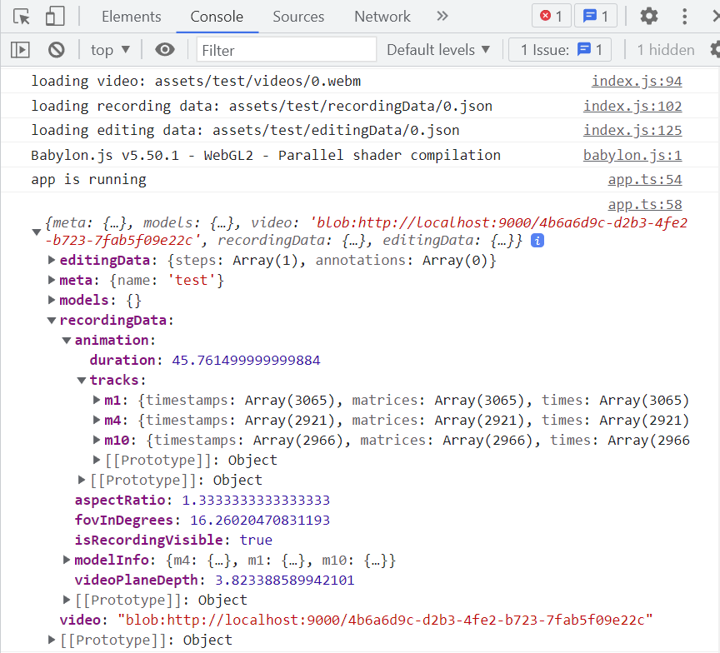

## Animation Controls

**app.ts**

Replace with the following codes:

// sphere.animations = [animation];

    // scene.beginAnimation(sphere, 0, length - 1, true);

    const animationGroup = new AnimationGroup("animation group", scene);

    animationGroup.addTargetedAnimation(animation, sphere);

Here:

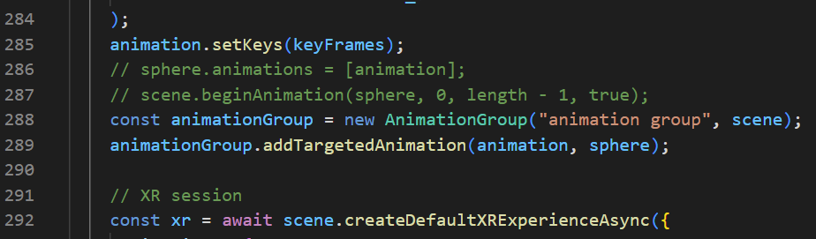

Add the following codes:

animationGroup.play(true)

Add the following codes:

animationGroup.pause()

Here:

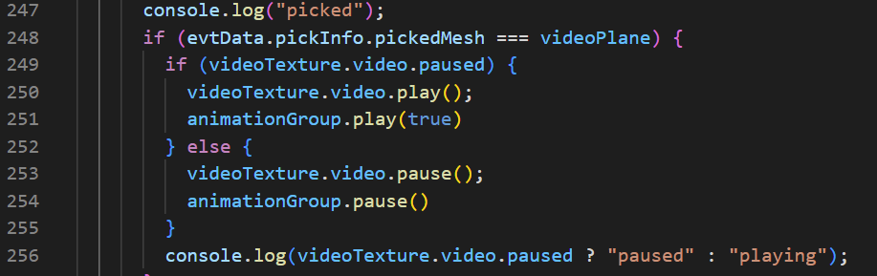

**Check**

Now the animation will only play when you click to start the XRAuthor video. The animation will also pause when the video pauses.

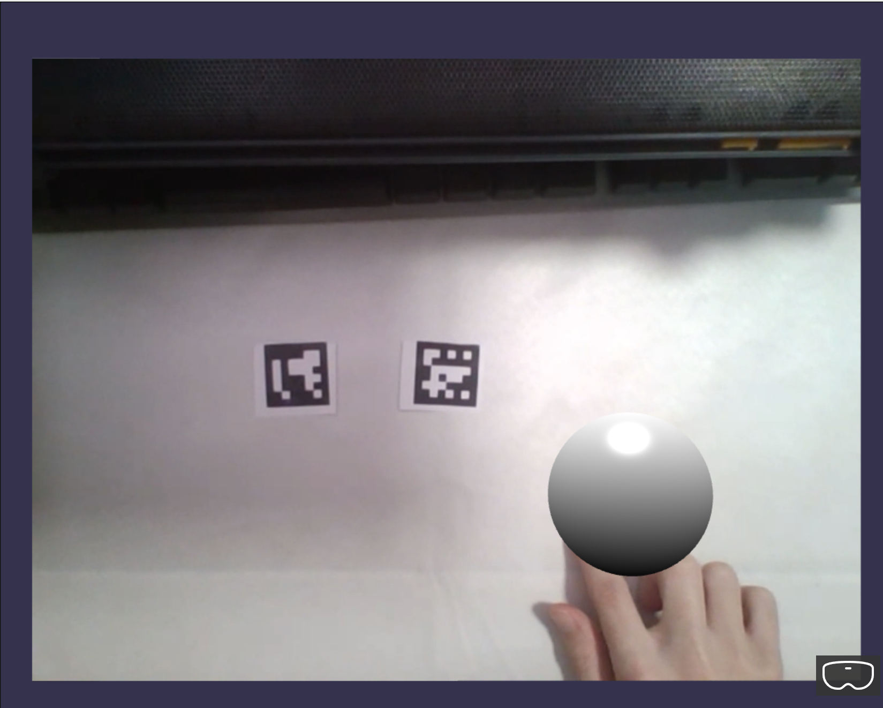

## Load and Animate Models

Enter the following commands:

npm i babylonjs-loaders

**app.ts**

Add the following codes:

//animationGroup.addTargetedAnimation(animation, sphere);

    //Loading Models from XRAuthor Video

    const info = this.data.recordingData.modelInfo[id];

    const label = info.label;

    const name = info.name;

    const url = this.data.models[name];

    SceneLoader.AppendAsync(url, undefined, scene, undefined, ".glb").then(

      (result) => {

        const root = result.getMeshById("__root__");

        root.id = id + ": " + label;

        root.name = label;

        animationGroup.addTargetedAnimation(animation, root);

        animationGroup.reset();

      }

    );

Here:

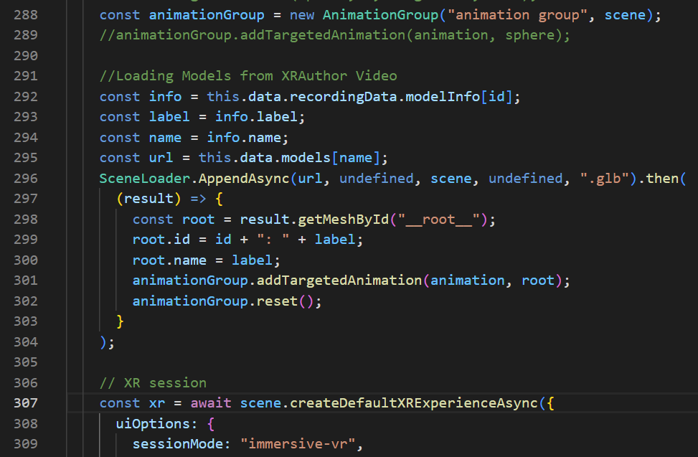

**Check**

You should be able to see the Model used in the XRAuthor video replaced with the original Sphere model on your QR code. In my case, my QR code (with label 10) has a H2O model.

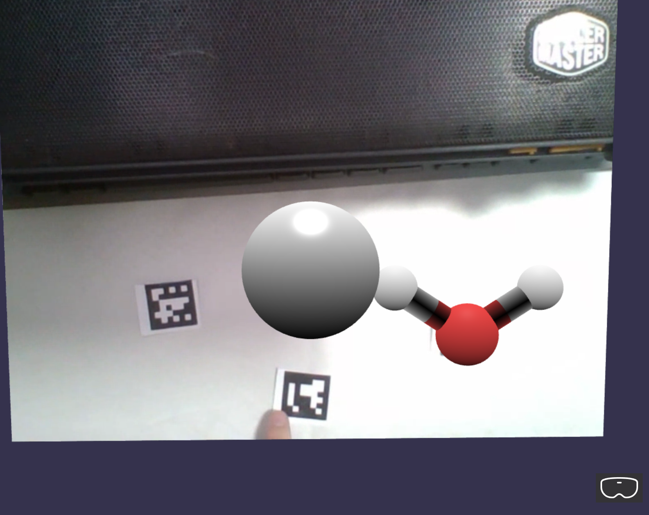

## Adding Labels and Text to Models

**app.ts**

Add the following codes:

    //Hello Text

    const helloPlane = MeshBuilder.CreatePlane(

      "hello plane",

      { width: 2.5, height: 1 },

      scene

    );

    const helloTexture = AdvancedDynamicTexture.CreateForMesh(

      helloPlane,

      250,

      100,

      false

    );

    helloTexture.name = "hello texture";

    const helloText= new TextBlock("hello text");

    helloText.color = "purple";

    helloText.fontSize = 60;

    helloTexture.addControl(helloText);

Here:

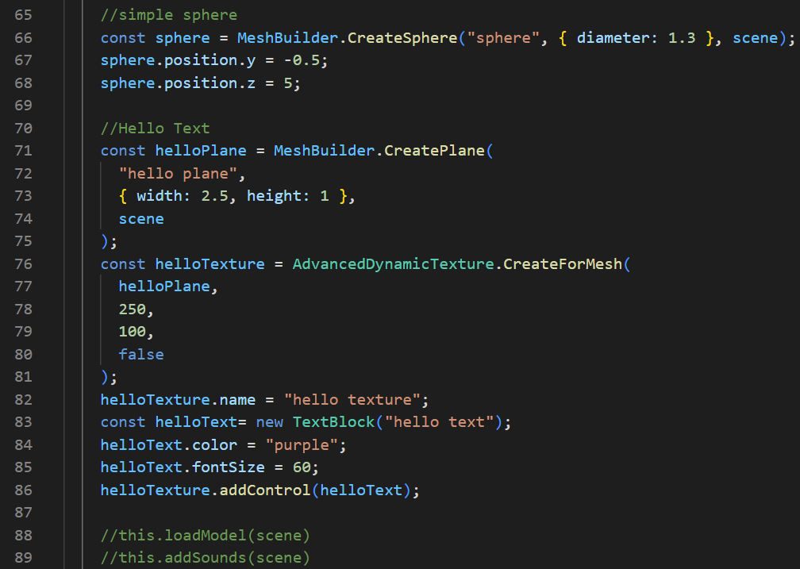

Add the following codes:

//Label text

        helloPlane.position.setAll(0);

        helloPlane.position.y = -0.5;

        helloPlane.position.z = -0.1;

        helloPlane.setParent(root);

        helloText.text = label;

Here:

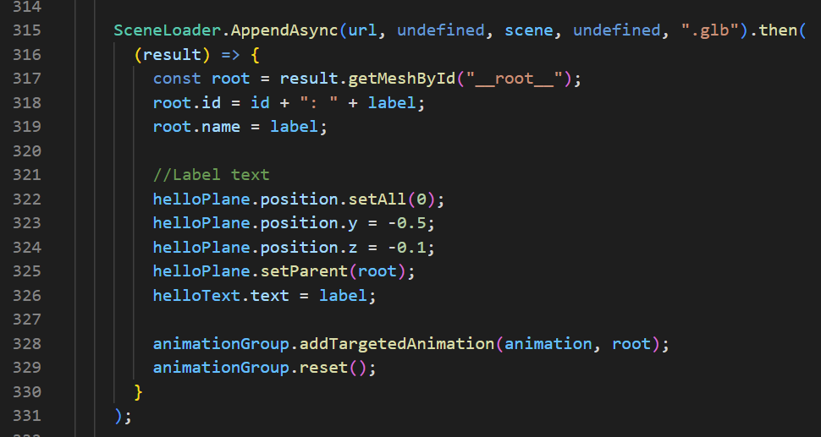

**Check**

You should be able to see the Label of your Model displayed below the Model.

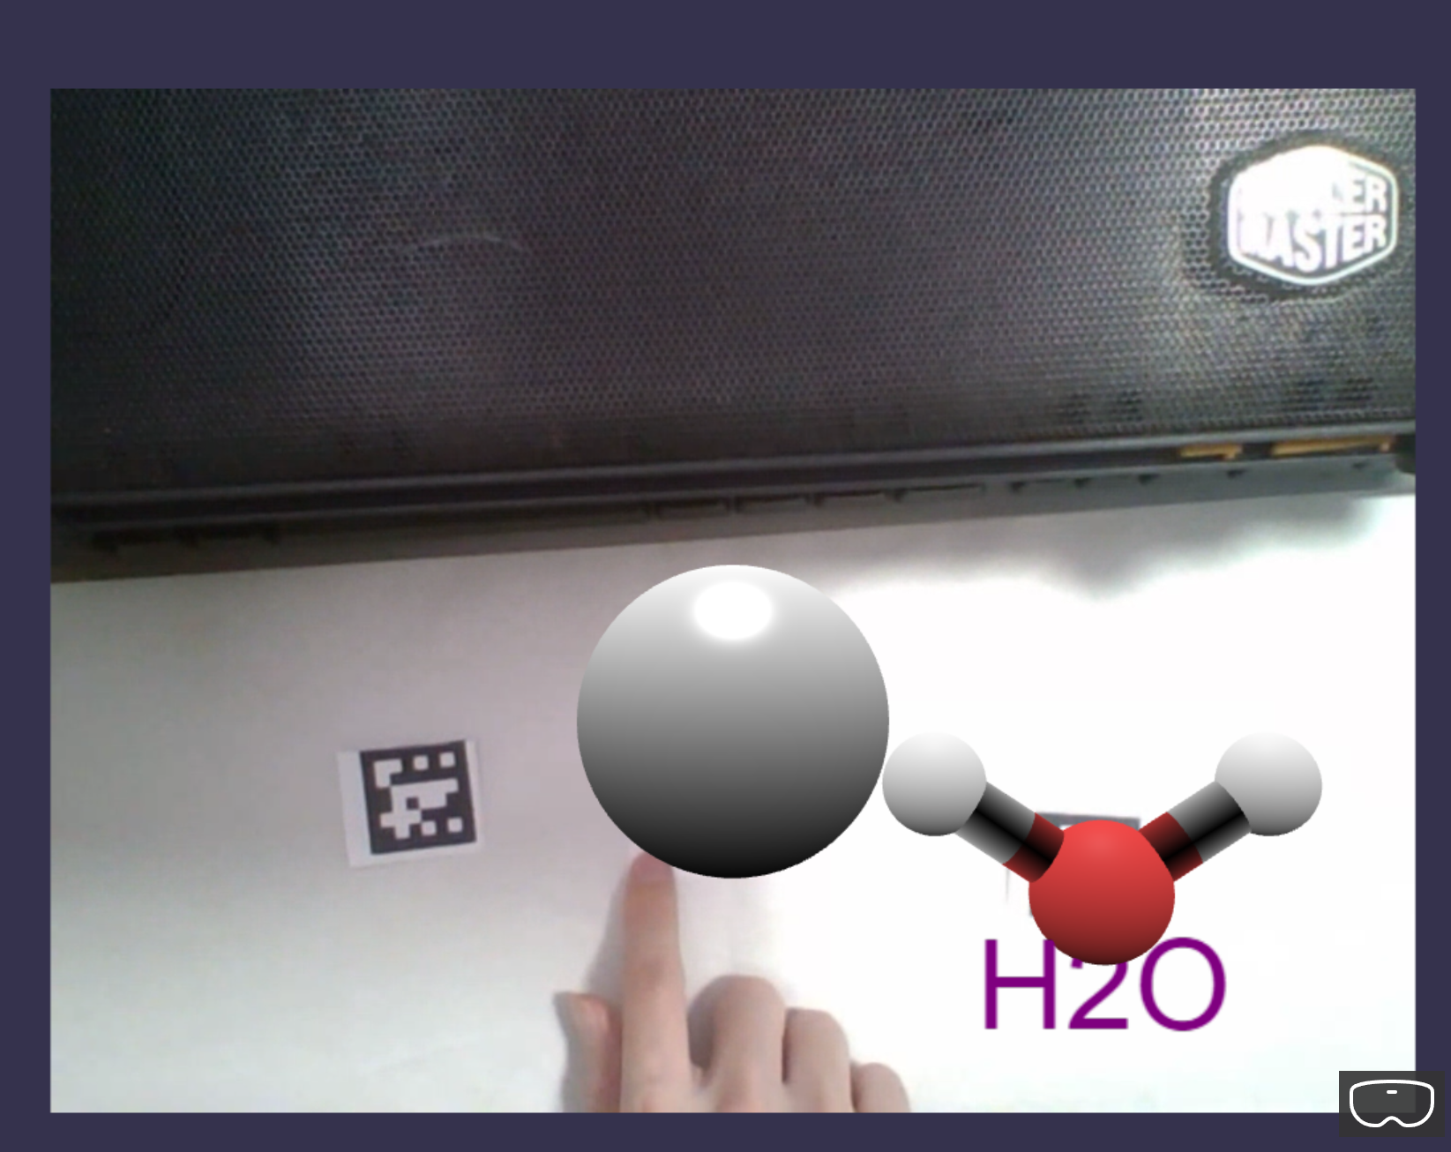

## Final Code Changes

### init.ts

import { Engine } from "babylonjs";

import { AuthoringData } from "xrauthor-loader";

import { App } from "./app";

export function createXRScene(

  canvasID: string,

  authoringData: AuthoringData,

) {

  const canvas = <HTMLCanvasElement>document.getElementById(canvasID);

  const engine = new Engine(canvas, true);

  const app = new App(engine, canvas, authoringData);

  const scene = app.createScene();

  const scenePromise = app.createScene();

  scenePromise.then((scene) => {

    engine.runRenderLoop(() => {

      scene.render();

    });

  });

  window.addEventListener("resize", () => {

    engine.resize();

  });

}

### index.ts

import {AuthoringData, loadAuthoringData} from 'xrauthor-loader'

import {createXRScene} from './init'

loadAuthoringData('assets/test').then((data: AuthoringData) => {

    createXRScene('renderCanvas', data)

})

### webpack.config.js

const path = require("path");

const HtmlWebpackPlugin = require('html-webpack-plugin')

const CopyPlugin = require('copy-webpack-plugin')

module.exports = {

    entry: './src/index.ts',

    output: {

        filename: 'index.js',

        path: path.resolve(__dirname, 'dist/app')

    },

    resolve: {

        extensions: [".ts", ".js"]

    },

    module: {

        rules: [

            { test: /\.tsx?$/, loader: "ts-loader" }

        ]

    },

    mode: "development",

    devtool: 'inline-source-map',

    devServer: {

        //static: false,

        port: 9000,

        server: 'http'

    },

    plugins: [

        new HtmlWebpackPlugin({

            template: path.resolve(__dirname,'src/index.html')

        }),

        new CopyPlugin({

            patterns: [

                { from: path.resolve(__dirname, 'public')}

            ]

        }),

    ]

};

### app.ts

import {

  ArcRotateCamera,

  Color3,

  CubeTexture,

  Engine,

  MeshBuilder,

  Scene,

  StandardMaterial,

  Texture,

  Vector3,

  UniversalCamera,

  HemisphericLight,

  PointLight,

  VideoDome,

  SceneLoader,

  AbstractMesh,

  Animation,

  ParticleSystem,

  Color4,

  Sound,

  PointerDragBehavior,

  ActionManager,

  Observable,

  Observer,

  Tools,

  WebXRFeaturesManager,

  WebXRDefaultExperience,

  Mesh,

  WebXRFeatureName,

  WebXRMotionControllerTeleportation,

  TransformNode,

  MultiPointerScaleBehavior,

  GizmoManager,

  PointerEventTypes,

  VideoTexture,

  Matrix,

  AnimationGroup,

} from "babylonjs";

import { AdvancedDynamicTexture, TextBlock } from "babylonjs-gui";

import "babylonjs-loaders";

import { AuthoringData } from "xrauthor-loader";

import { HelloSphere, TextPlane } from "./components/meshes";

export class App {

  private engine: Engine;

  private canvas: HTMLCanvasElement;

  private data: AuthoringData;

  private sound: Sound;

  constructor(engine: Engine, canvas: HTMLCanvasElement, data: AuthoringData) {

    this.engine = engine;

    this.canvas = canvas;

    this.data = data;

    console.log("app is running");

  }

  async createScene() {

    console.log(this.data);

    const scene = new Scene(this.engine);

    scene.createDefaultCameraOrLight(false, true, true);

    //this.createCamera(scene)

    //this.createLights(scene)

    scene.actionManager = new ActionManager(scene);

    //simple sphere

    const sphere = MeshBuilder.CreateSphere("sphere", { diameter: 1.3 }, scene);

    sphere.position.y = -0.5;

    sphere.position.z = 5;

    //Hello Text

    const helloPlane = MeshBuilder.CreatePlane(

      "hello plane",

      { width: 2.5, height: 1 },

      scene

    );

    const helloTexture = AdvancedDynamicTexture.CreateForMesh(

      helloPlane,

      250,

      100,

      false

    );

    helloTexture.name = "hello texture";

    const helloText= new TextBlock("hello text");

    helloText.color = "purple";

    helloText.fontSize = 60;

    helloTexture.addControl(helloText);

    //this.loadModel(scene)

    //this.addSounds(scene)

    //this.createText(scene);

    //hello sphere

    const helloSphere = new HelloSphere("hello sphere", { diameter: 1 }, scene);

    helloSphere.position.set(0, 1, 5);

    helloSphere.sayHello("this a test.");

    helloSphere.isPickable = true;

    helloSphere.setEnabled(false); //temporary disable

    //ground

    const groundMaterial = new StandardMaterial("ground material", scene);

    groundMaterial.backFaceCulling = true;

    groundMaterial.diffuseTexture = new Texture(

      "assets/textures/grass.png",

      scene

    );

    const ground = MeshBuilder.CreateGround(

      "ground",

      { width: 12, height: 12 },

      scene

    );

    ground.material = groundMaterial;

    ground.position.set(0, -1, 8);

    ground.setEnabled(false); //temporary disable

    //interactions

    //use behaviors

    const pointerDragBehavior = new PointerDragBehavior({

      dragPlaneNormal: Vector3.Up(),

    });

    pointerDragBehavior.onDragStartObservable.add((evtData) => {

      console.log(

        "drag start: pointer id -" + pointerDragBehavior,

        evtData.pointerId

      );

      console.log(evtData);

    });

    //sphere.addBehavior(pointerDragBehavior);

    const helloSphereDragBehavior = new PointerDragBehavior({

      dragPlaneNormal: Vector3.Backward(),

    });

    helloSphere.addBehavior(helloSphereDragBehavior);

    //multiple pointer scale

    const multiPointerScaleBehavior = new MultiPointerScaleBehavior();

    helloSphere.addBehavior(multiPointerScaleBehavior);

    //more behaviors

    //default gizmo

    // const gizmoManager = new GizmoManager(scene);

    // gizmoManager.positionGizmoEnabled = true

    // gizmoManager.rotationGizmoEnabled = true

    // gizmoManager.scaleGizmoEnabled = true

    // gizmoManager.boundingBoxGizmoEnabled = true;

    //this.createSkybox(scene);

    //this.createVideoSkyDome(scene);

    //use observables (@ Can be shifted to hello-mesh.ts class)

    //1. create an observable for detecting intersections

    const onIntersectObservable = new Observable<boolean>();

    scene.registerBeforeRender(function () {

      const isIntersecting = sphere.intersectsMesh(helloSphere, true, true);

      onIntersectObservable.notifyObservers(isIntersecting);

    });

    helloSphere.onInterectObservable = onIntersectObservable;

    const redColor = Color3.Red();

    const whiteColor = Color3.White();

    helloSphere.onInterectObservable.add((isIntersecting) => {

      const material = helloSphere.mesh.material as StandardMaterial;

      const isRed = material.diffuseColor === redColor;

      if (isIntersecting && !isRed) {

        material.diffuseColor = redColor;

      } else if (!isIntersecting && isRed) {

        material.diffuseColor = whiteColor;

      }

    });

    //2. create an observable for check distance

    const onDistanceChangeObservable = new Observable<number>();

    let previousState: number = null;

    scene.onBeforeRenderObservable.add(() => {

      const currentState = Vector3.Distance(

        sphere.position,

        helloSphere.position

      );

      if (currentState !== previousState) {

        console.log("distance updated!");

        previousState = currentState;

        onDistanceChangeObservable.notifyObservers(currentState);

      }

    });

    helloSphere.onDistanceChangeObservable = onDistanceChangeObservable;

    const blueColor = Color3.Blue();

    helloSphere.onDistanceChangeObservable.add((distance) => {

      const isCloseEnough = distance <= 1.2;

      const material = helloSphere.mesh.material as StandardMaterial;

      const isBlue = material.diffuseColor === blueColor;

      const isRed = material.diffuseColor === redColor;

      if (isCloseEnough && !isBlue && !isRed) {

        material.diffuseColor = blueColor;

      } else if (!isCloseEnough && isBlue) {

        material.diffuseColor = whiteColor;

      }

    });

    //3. create observer (Display distance on text block)

    const observer = new Observer<number>((distance) => {

      helloSphere.label.textBlock.text = "d: " + distance.toFixed(2);

    }, -1);

    //onDistanceChangeObservable.observers.push(observer)

    //4. add observer using coroutine

    const addObserverCoroutine = function* () {

      console.log("frame " + scene.getFrameId() + ": do nothing");

      yield;

      console.log("frame " + scene.getFrameId() + ": add observer");

      onDistanceChangeObservable.observers.push(observer);

      yield;

      console.log("frame " + scene.getFrameId() + ": do nothing");

    };

    scene.onBeforeRenderObservable.runCoroutineAsync(addObserverCoroutine());

    const coroutine = function* () {

      (async function () {

        await Tools.DelayAsync(2000);

        console.log("frame " + scene.getFrameId() + ": fn 1");

      })();

      yield;

      (async function () {

        await Tools.DelayAsync(2000);

        console.log("frame " + scene.getFrameId() + ": fn 2");

      })();

      yield;

      (async function () {

        console.log("frame " + scene.getFrameId() + ": fn 3");

      })();

      yield Tools.DelayAsync(1000);

      (async function () {

        console.log("frame " + scene.getFrameId() + ": fn 4");

      })();

    };

    scene.onBeforeRenderObservable.runCoroutineAsync(coroutine());

    this.addInspectorKeyboardShortcut(scene);

    //XRAuthor Video

    const videoHeight = 5;

    const videoWidth = videoHeight * this.data.recordingData.aspectRatio;

    const videoPlane = MeshBuilder.CreatePlane(

      "video plane",

      {

        height: videoHeight,

        width: videoWidth,

      },

      scene

    );

    videoPlane.position.z = 6;

    const videoMaterial = new StandardMaterial("video material", scene);

    const videoTexture = new VideoTexture(

      "video texture",

      this.data.video,

      scene

    );

    videoTexture.video.autoplay = false;

    videoTexture.onUserActionRequestedObservable.add(() => {});

    videoMaterial.diffuseTexture = videoTexture;

    videoMaterial.roughness = 1;

    videoMaterial.emissiveColor = Color3.White();

    videoPlane.material = videoMaterial;

    scene.onPointerObservable.add((evtData) => {

      console.log("picked");

      if (evtData.pickInfo.pickedMesh === videoPlane) {

        if (videoTexture.video.paused) {

          videoTexture.video.play();

          animationGroup.play(true);

        } else {

          videoTexture.video.pause();

          animationGroup.pause();

        }

        console.log(videoTexture.video.paused ? "paused" : "playing");

      }

    }, PointerEventTypes.POINTERPICK);

    //XRAuthor Animation

    const id = "m10";

    const track = this.data.recordingData.animation.tracks[id];

    console.log("what value" + this.data.recordingData.animation.tracks);

    const length = track.times.length;

    const fps = length / this.data.recordingData.animation.duration;

    const keyFrames = [];

    for (let i = 0; i < length; i++) {

      const mat = Matrix.FromArray(track.matrices[i].elements);

      const pos = mat.getTranslation();

      //convert position from right handed to left handed coords

      pos.z = -pos.z;

      const s = 6 / pos.z;

      keyFrames.push({

        frame: track.times[i] * fps,

        value: pos.scale(s).multiplyByFloats(3, 3, 1),

      });

    }

    const animation = new Animation(

      "animation",

      "position",

      fps,

      Animation.ANIMATIONTYPE_VECTOR3,

      Animation.ANIMATIONLOOPMODE_CYCLE

    );

    animation.setKeys(keyFrames);

    // sphere.animations = [animation];

    // scene.beginAnimation(sphere, 0, length - 1, true);

    const animationGroup = new AnimationGroup("animation group", scene);

    //animationGroup.addTargetedAnimation(animation, sphere);

    //Loading Models from XRAuthor Video

    const info = this.data.recordingData.modelInfo[id];

    const label = info.label;

    const name = info.name;

    const url = this.data.models[name];

    SceneLoader.AppendAsync(url, undefined, scene, undefined, ".glb").then(

      (result) => {

        const root = result.getMeshById("__root__");

        root.id = id + ": " + label;

        root.name = label;

        //Label text

        helloPlane.position.setAll(0);

        helloPlane.position.y = -0.5;

        helloPlane.position.z = -0.1;

        helloPlane.setParent(root);

        helloText.text = label;

        animationGroup.addTargetedAnimation(animation, root);

        animationGroup.reset();

      }

    );

    // XR session

    const xr = await scene.createDefaultXRExperienceAsync({

      uiOptions: {

        sessionMode: "immersive-vr",

        //sessionMode: 'immersive-ar'

      },

    });

    //only for debugging

    (window as any).xr = xr;

    const featureManager = xr.baseExperience.featuresManager;

    console.log(WebXRFeaturesManager.GetAvailableFeatures());

    //locomotion

    const movement = MovementMode.Teleportation; //Teleportation, Contoller, Walk

    this.initLocomotion(movement, xr, featureManager, ground, scene);

    //hand tracking (Requires Oculus Quest 2)

    try {

      featureManager.enableFeature(WebXRFeatureName.HAND_TRACKING, "latest", {

        xrInput: xr.input,

        jointMeshes: {

          disableDefaultHandMesh: false,

          // disableDefaultHandMesh: true,

        },

      });

    } catch (error) {

      console.log(error);

    }

    //hand/controller drag

    let mesh: AbstractMesh;

    xr.input.onControllerAddedObservable.add((controller) => {

      controller.onMotionControllerInitObservable.add((motionController) => {

        // const ids = motionController.getComponentIds()

        // const trigger = motionController.getComponent(ids[0])

        const trigger = motionController.getComponentOfType("trigger");

        trigger.onButtonStateChangedObservable.add(() => {

          if (trigger.changes.pressed) {

            if (

              (mesh = xr.pointerSelection.getMeshUnderPointer(

                controller.uniqueId

              ))

            ) {

              console.log("mesh under controller pointer: " + mesh.name);

              if (mesh.name !== "ground") {

                const distance = Vector3.Distance(

                  motionController.rootMesh.getAbsolutePosition(),

                  mesh.getAbsolutePosition()

                );

                console.log("distance: " + distance);

                if (distance < 1) {

                  mesh.setParent(motionController.rootMesh);

                  console.log("grab mesh: " + mesh.name);

                }

              }

            } else {

              if (mesh && mesh.parent) {

                mesh.setParent(null);

                console.log("release mesh: " + mesh.name);

              }

            }

          }

        });

      });

    });

    return scene;

  }

  createCamera(scene: Scene) {

    //const camera = new ArcRotateCamera('arcCamera', -Math.PI/5, -Math.PI/2, 5, Vector3.Zero(), scene)

    const camera = new UniversalCamera(

      "uniCamera",

      new Vector3(0, 0, -5),

      scene

    );

    camera.attachControl(this.canvas, true);

  }

  createLights(scene: Scene) {

    const hemiLight = new HemisphericLight(

      "hemLight",

      new Vector3(-1, 1, 0),

      scene

    );

    hemiLight.intensity = 0.5;

    hemiLight.diffuse = new Color3(1, 1, 1);

    const pointLight = new PointLight(

      "pointLight",

      new Vector3(0, 1.5, 2),

      scene

    );

    pointLight.intensity = 1;

    pointLight.diffuse = new Color3(1, 0, 0);

  }

  loadModel(scene: Scene) {

    SceneLoader.ImportMeshAsync("", "assets/models/", "H2O.glb", scene).then(

      (result) => {

        const root = result.meshes[0];

        root.id = "h2oRoot";

        root.name = "h2oRoot";

        root.position.y = -1;

        root.rotation = new Vector3(0, 0, Math.PI);

        root.scaling.setAll(1.5);

        this.createAnimation(scene, root);

        this.createParticles(scene);

      }

    );

  }

  createAnimation(scene: Scene, model: AbstractMesh) {

    const animation = new Animation(

      "rotationAnima",

      "rotation",

      30,

      Animation.ANIMATIONTYPE_VECTOR3,

      Animation.ANIMATIONLOOPMODE_CYCLE

    );

    const keyFrames = [

      { frame: 0, value: new Vector3(0, 0, 0) },

      { frame: 30, value: new Vector3(0, 2 * Math.PI, 0) },

    ];

    animation.setKeys(keyFrames);

    model.animations = [];

    model.animations.push(animation);

    scene.beginAnimation(model, 0, 30, true);

  }

  createParticles(scene: Scene) {

    const particleSystem = new ParticleSystem("particles", 5000, scene);

    particleSystem.particleTexture = new Texture(

      "assets/textures/flare.png",

      scene

    );

    particleSystem.emitter = new Vector3(0, 0, 0);

    particleSystem.minEmitBox = new Vector3(0, 0, 0);

    particleSystem.maxEmitBox = new Vector3(0, 0, 0);

    particleSystem.color1 = new Color4(0.7, 0.8, 1.0, 1.0);

    particleSystem.color2 = new Color4(0.3, 0.5, 1.0, 1.0);

    particleSystem.blendMode = ParticleSystem.BLENDMODE_ONEONE;

    particleSystem.minSize = 0.01;

    particleSystem.maxSize = 0.05;

    particleSystem.minLifeTime = 0.3;

    particleSystem.maxLifeTime = 1.5;

    particleSystem.emitRate = 1500;

    particleSystem.direction1 = new Vector3(-1, 8, 1);

    particleSystem.direction2 = new Vector3(1, 8, -1);

    particleSystem.minEmitPower = 0.2;

    particleSystem.maxEmitPower = 0.8;

    particleSystem.updateSpeed = 0.01;

    particleSystem.gravity = new Vector3(0, -9.8, 0);

    particleSystem.start();

  }

  addSounds(scene: Scene) {

    const music = new Sound(

      "music",

      "assets/sounds/hello-xr.mp3",

      scene,

      null,

      {

        loop: true,

        autoplay: false,

      }

    );

    this.sound = new Sound("sound", "assets/sounds/button.mp3", scene, null);

  }

  createText(scene: Scene) {

    const helloPlane = new TextPlane(

      "hello plane",

      3,

      1,

      0,

      2,

      5,

      "Hello XR",

      "white",

      "purple",

      60,

      scene

    );

    helloPlane.textBlock.onPointerUpObservable.add((evtData) => {

      alert("Hello Text at: \n x: " + evtData.x + " y:" + evtData.y);

    });

    helloPlane.textBlock.onPointerDownObservable.add(() => {

      this.sound.play();

    });

  }

  createSkybox(scene: Scene) {

    const skybox = MeshBuilder.CreateBox("skybox", { size: 1000 }, scene);

    const skyboxMaterial = new StandardMaterial("skybox-mat");

    skyboxMaterial.backFaceCulling = false;

    skyboxMaterial.reflectionTexture = new CubeTexture(

      "assets/textures/skybox",

      scene

    );

    skyboxMaterial.reflectionTexture.coordinatesMode = Texture.SKYBOX_MODE;

    skyboxMaterial.diffuseColor = new Color3(0, 0, 0);

    skyboxMaterial.specularColor = new Color3(0, 0, 0);

    skybox.material = skyboxMaterial;

  }

  createVideoSkyDome(scene: Scene) {

    const dome = new VideoDome(

      "videoDome",

      "assets/videos/bridge-360.mp4",

      {

        resolution: 32,

        size: 1000,

      },

      scene

    );

  }

  addInspectorKeyboardShortcut(scene: Scene) {

    window.addEventListener("keydown", (e) => {

      if (e.ctrlKey && e.key === "i") {

        if (scene.debugLayer.isVisible()) scene.debugLayer.hide();

        else scene.debugLayer.show();

      }

    });

  }

  initLocomotion(

    movement: MovementMode,

    xr: WebXRDefaultExperience,

    featureManager: WebXRFeaturesManager,

    ground: Mesh,

    scene: Scene

  ) {

    switch (movement) {

      case MovementMode.Teleportation:

        console.log("movement mode: teleportation");

        const teleportation = featureManager.enableFeature(

          WebXRFeatureName.TELEPORTATION,

          "stable",

          {

            xrInput: xr.input,

            floorMeshes: [ground],

            timeToTeleport: 2000,

            useMainComponentOnly: true,

            defaultTargetMeshOptions: {

              teleportationFillColor: "#55FF99",

              teleportationBorderColor: "blue",

              torusArrowMaterial: ground.material,

            },

          },

          true,

          true

        ) as WebXRMotionControllerTeleportation;

        teleportation.parabolicRayEnabled = true;

        teleportation.parabolicCheckRadius = 2;

        break;

      case MovementMode.Contoller:

        console.log("movement mode: controller");

        featureManager.disableFeature(WebXRFeatureName.TELEPORTATION);

        featureManager.enableFeature(WebXRFeatureName.MOVEMENT, "latest", {

          xrInput: xr.input,

        });

        break;

      case MovementMode.Walk:

        console.log("movement mode: walk");

        featureManager.disableFeature(WebXRFeatureName.TELEPORTATION);

        const xrRoot = new TransformNode("xr root", scene);

        xr.baseExperience.camera.parent = xrRoot;

        featureManager.enableFeature(

          WebXRFeatureName.WALKING_LOCOMOTION,

          "latest",

          {

            locomotionTarget: xrRoot,

          }

        );

        break;

    }

  }

}

enum MovementMode {

  Teleportation,

  Contoller,

  Walk,

}

### index-ext.ts

import { createXRScene } from './init'

window['extension'] = { createXRScene: createXRScene }

### webpack.ext.js

const path = require("path");

module.exports =

{

    entry: path.resolve(__dirname, 'src/index-ext.ts'),

    output: {

        filename: 'index.js',

        path: path.resolve(__dirname, 'dist/ext')

    },

    resolve: {

        extensions: ['.ts']

    },

    module: {

        rules: [

            { test: /\.tsx?$/, loader: "ts-loader" }

        ]

    },

    mode: 'production',

}